Contrast Stretching
Code:
import cv2
import numpy as np
import matplotlib.pyplot as plt
image = cv2.imread('erkan.jpg', cv2.IMREAD_GRAYSCALE)
def contrast_stretching(image):
min_val = np.min(image)
max_val = np.max(image)
stretched = ((image - min_val) / (max_val - min_val) * 255).astype(np.uint8)
return stretched
stretched_image = contrast_stretching(image)
plt.figure(figsize=(12, 6))
plt.subplot(1, 2, 1)
plt.title("Original Image")
plt.imshow(image, cmap='gray')
plt.axis('off')
plt.subplot(1, 2, 2)
plt.title("Contrast Stretched Image")
plt.imshow(stretched_image, cmap='gray')
plt.axis('off')
plt.show()
cv2.imwrite('contrast_stretched_erkan.jpg', stretched_image)
Code Explanation
This code performs contrast stretching on a grayscale image using NumPy and OpenCV, and then visualizes the original and processed images using Matplotlib.
Step-by-Step Explanation
- Import Required Libraries:
  - cv2: To handle image loading and saving.
  - numpy: For numerical operations, including pixel intensity computations.
  - matplotlib.pyplot: To visualize the images.
- Image Loading:
image = cv2.imread('erkan.jpg', cv2.IMREAD_GRAYSCALE)
  - The image is read in grayscale mode using OpenCV, which means pixel intensities range between 0 (black) and 255 (white).
- Contrast Stretching Function:
def contrast_stretching(image):
min_val = np.min(image)
max_val = np.max(image)
stretched = ((image - min_val) / (max_val - min_val) * 255).astype(np.uint8)
return stretched
  - Compute Minimum and Maximum Intensities: np.min(image) and np.max(image) determine the darkest and brightest pixel values.
  - Stretch Intensities: The formula rescales pixel values linearly to the full 0–255 range, ensuring better contrast.
- Processing the Image:
stretched_image = contrast_stretching(image)
  - The contrast_stretching function is applied to the grayscale image, producing a contrast-enhanced version.
- Visualizing Results:
plt.figure(figsize=(12, 6))
plt.subplot(1, 2, 1)
plt.title("Original Image")
plt.imshow(image, cmap='gray')
plt.axis('off')
plt.subplot(1, 2, 2)
plt.title("Contrast Stretched Image")
plt.imshow(stretched_image, cmap='gray')
plt.axis('off')
plt.show()
  - Displays the original and enhanced images side by side using Matplotlib.
- Saving the Result:
cv2.imwrite('contrast_stretched_erkan.jpg', stretched_image)
  - The processed image is saved as contrast_stretched_erkan.jpg.

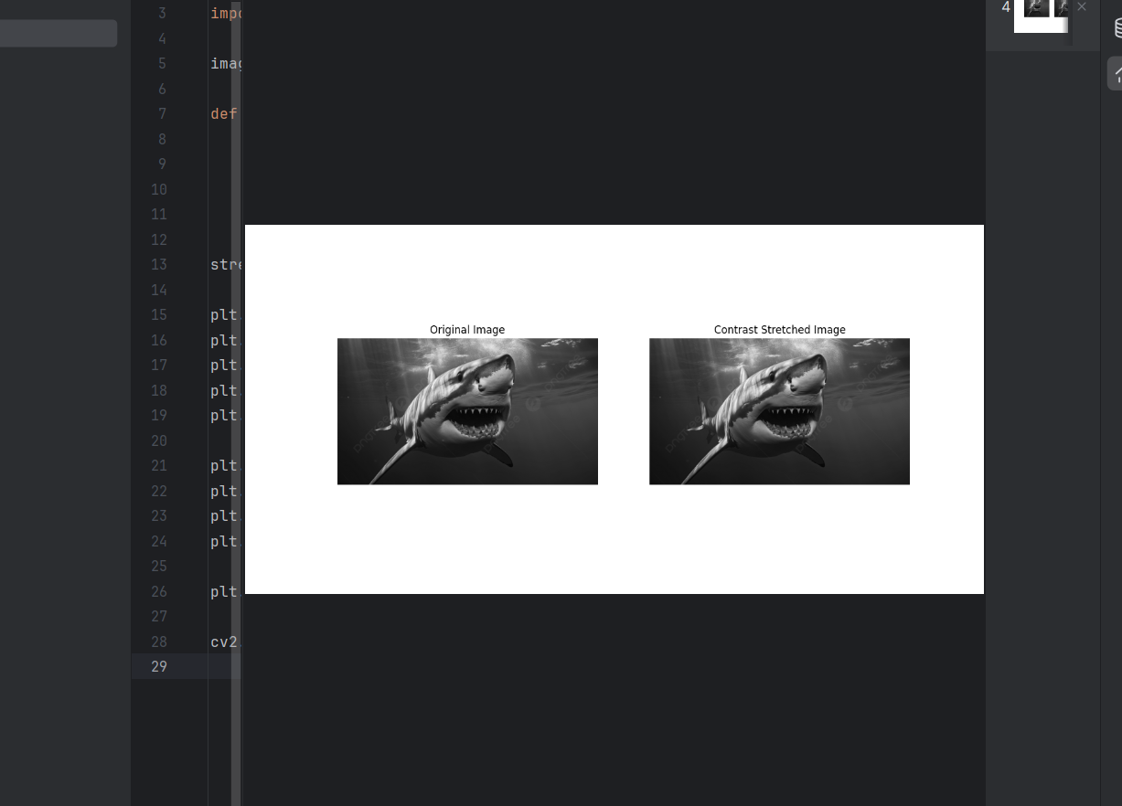
Output:

Report
Objective;
The goal of this project is to enhance the contrast of a grayscale image using contrast stretching, improving its visual quality and detail clarity.
Process
- Input Analysis:
  - The input image is read in grayscale mode.
  - Pixel intensity distribution spans a limited range (e.g., [50, 200]).
- Contrast Stretching:
  - Linearly maps the pixel intensity range of the input image to the full 0–255 range.
  - This increases the image's dynamic range, making features more distinguishable.
- Output Analysis:
  - The enhanced image exhibits higher contrast, with darker areas appearing more pronounced and bright areas more vivid.
  - The visual improvement is evident in the Matplotlib comparison.
Results
- The enhanced image was successfully saved as contrast_stretched_erkan.jpg.
- The technique is particularly effective for images with limited contrast but may introduce artifacts if noise is present.
Recommendations
- For better control, percentile-based stretching can be applied to avoid the influence of outliers.
- Use histogram analysis to verify the improvement in pixel intensity distribution.

